EENG 385 - Electronic Devices and Circuits
PID Controller
Handout

PID Controller
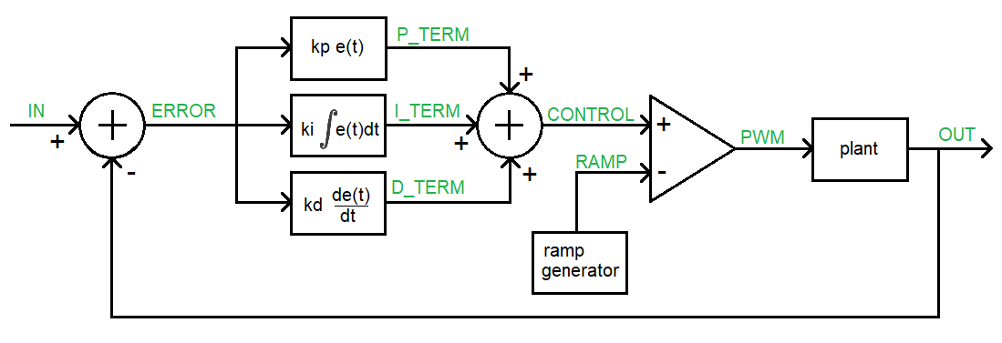
Figure 1: High-level architecture of the PID Controller board.
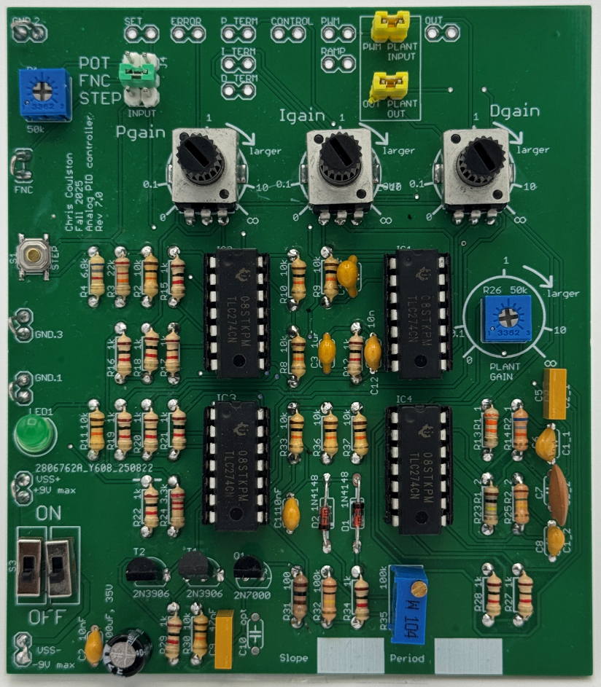
Figure 2: An assembled PID Controller board. The headers at the top of the board provide access to the values of the PID control loop using an oscilloscope.

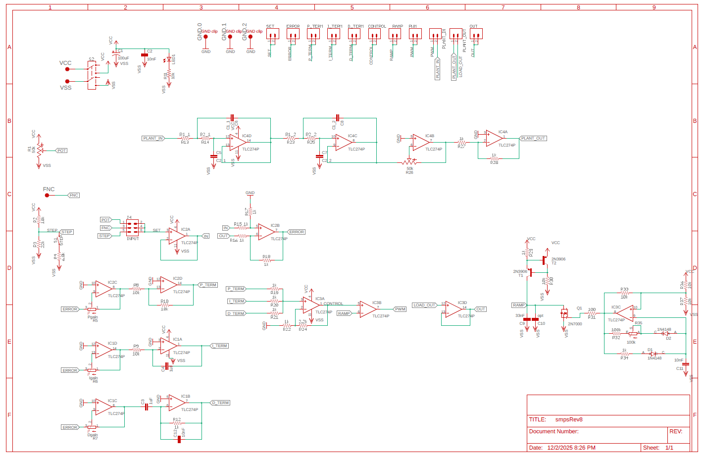

Circuit Operation:
- The first summer junction
  - What opamp and resistors form the summer junction that outputs ERROR Figure 1?
IC2B, R15, R16, R17, R18
  - Write an equation for the output ERROR in terms of IN and OUT.
ERROR = IN - OUT
- The proportional term, P_TERM, is formed by two opamps. ERROR is the input to the first stage and P_TERM is the output from the second stage.
  - What opamp/resistors in the form the first stage of the P_TERM in Figure 1?
IC2C, R5
  - What is the range of the gain of this circuit? Make sure to include the sign.
This is an inverting configuration so Gain = – R2/R2 [0, -∞]
  - What opamp/resistors form the second stage of the P_TERM in Figure 1?
IC2D, R8, R10
  - What is the gain of this second stage?
This is an inverting configuration so Gain = – R2/R2 = -1
  - What is the purpose of this second opamp stage?
Invert the gain from the first stage so the overall gain is positive.
  - Why didn’t I use a non-inverting opamp instead of this 2-stage approach? Hint, look at your answer for part b.
Because the gain of a non-inverting configuration is 1+R2/R1, meaning that you can only form gains which are greater or equal to 1 and perhaps you would want a gain that is less than 1.
- The integral term, I_TERM, is formed by two opamps. ERROR is the input to the first stage and I_TERM is the output from the second stage.
  - What opamp/resistors in the form the first stage of the I_TERM in Figure 1?
IC1D, R6
  - Where have you seen this circuit before?
This is the same circuit as P_TERM circuit.
  - What opamp/resistors form the second stage of the I_TERM in Figure 1?
IC2D, R9, C4
  - Write an equation for the output of the second stage, I_TERM, in terms of the input (call it ERROR) and C and R. Use C and R in your equation, not their values of uF and 10kΩ.
I_TERM = 1/RC * ∫ERROR(t)
  - Why did I use an inverting integrator circuit instead of a non-inverting integrator?
So that you could have a gain in the range [0, -∞].
- The derivative term, D_TERM, is formed by two opamps. ERROR is the input to the first stage and D_TERM is the output from the second stage.
  - What opamp/resistors in the form the first stage of the D_TERM in Figure 1?
IC1C, R7
  - Where have you seen this circuit before?
This is the same circuit as P_TERM circuit.
  - What opamp/resistors form the second stage of the D_TERM in Figure 1?
IC1B, R12, C3
  - Write an equation for the output of the second stage, D_TERM, in terms of the input (call it ERROR) and C and R. Use C and R in your equation, not their values of 1uF and 10kΩ.
D_TERM = 1/RC * dERROR(t)/dt
  - Why did I use an inverting differentiator circuit instead of a non-inverting differentiator?
So that you could have a gain in the range [0, -∞].
- The second summer junction
  - What opamp and resistors form the summer junction that outputs CONTROL in Figure 1?
IC3A, R19, R20, R21, R22, R24
  - Write an equation for the output CONTROL in terms of P_TERM, I_TERM and D_TERM.
CONTROL = (P_TERM + I_TERM + D_TERM) / 3.3
  - What value “should” the 3.3kΩ have? Why did I choose 3.3kΩ instead of this value?
The value should have been 3kΩ because you should divide by 3 because you added 3 terms.
  - Why did I use an non-inverting summer instead of the simpler inverting summer?
To make the control signal have the same sign as the inputs.
- The ramp generator is uses the Schmitt Trigger Relaxation Oscillator that you built in Lab 2. Using your lab results will simplify answering the questions in this section.
  - What components form the Schmitt Trigger Relaxation Oscillator (STRO)?
IC3C, (optional R31) R32, R33, R34, R35, R36, R37, D1, D2, C11
  - What is the period/frequency and duty cycle of the waveform generated by the STRO? Assume that potentiometer R35 is set to 0Ω.
Period = 7ms, Frequency = 1/7ms = 143Hz with a duty cycle of 1%
  - Does R35 effect the time high or time low of the STRO waveform?
The potentiometer R35 effects the time low of the STRO waveform.
  - Components T1, T2, R29, and R30 forms a 0.7mA current source leaving the “bottom” of T1 (it’s collector). Assume that C10 is not populated, how long does it take to charge C9 from -9V to +9V? How would you describe the shape of the voltage vs. time waveform?
Since I = CdV/dt, then dV/dt = I/C which equals 0.7mA/100nF = 7000V/sec
In order to charge the capacitor from -9V to +9V, the capacitor would have to swing through 18V. So 18V*1sec/7000V = 2.6mS Since dV/dt is a constant, the waveform will be a straight line (ramp) from -9V to +9V.
  - What is the role of Q1 in generating the RAMP waveform?
Q1 periodically clears the charge off the capacitor pair C9, C10
  - What is the role of R35 is this circuit?
Allows us to adjust the period of the reset signal to clear the charge off C9, C10.
- The comparator
  - Given RAMP (in red) and CONTROL (in blue) shown in the following timing diagrams, draw the output PWM signal using the open-loop opamp configuration shown in Figure 1.
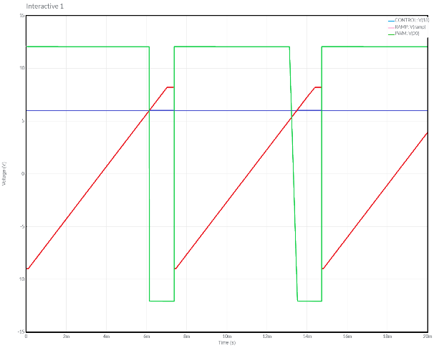 | 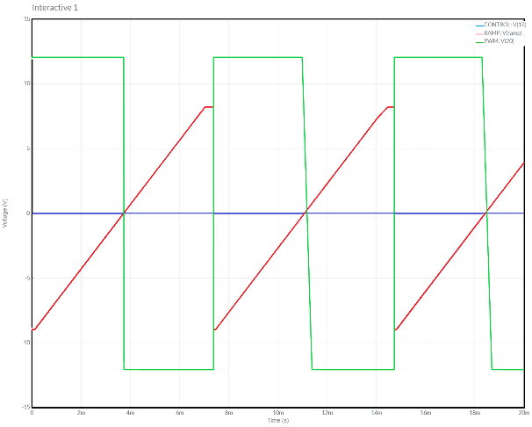 | 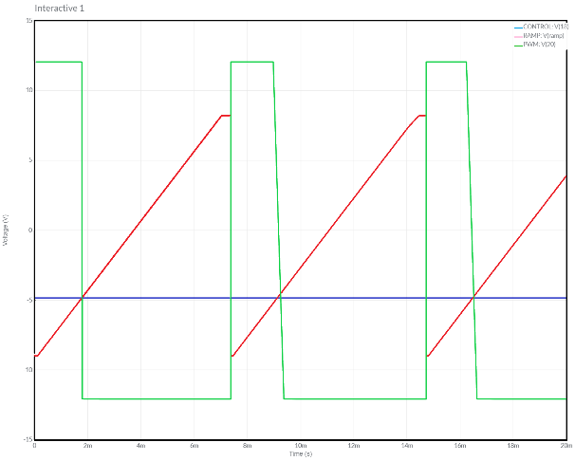

  - What is the relationship between the CONTROL signal and the duty cycle of the PWM signal? To determine this, plot the duty cycle vs control voltage and then write an equation to describe the straight-line y=mx+b style.
Duty cycle = 100/18 CONTROL + 50

The Plant:
The plant of the PID Controller board is a 4th order low pass filter built using opamps IC4D/C The gain of the plant is adjusted using the trimmer POT R26 attached to opam IC4B. Since this opamp is inverting, the final opamp is an inverting configuration with gain -1.
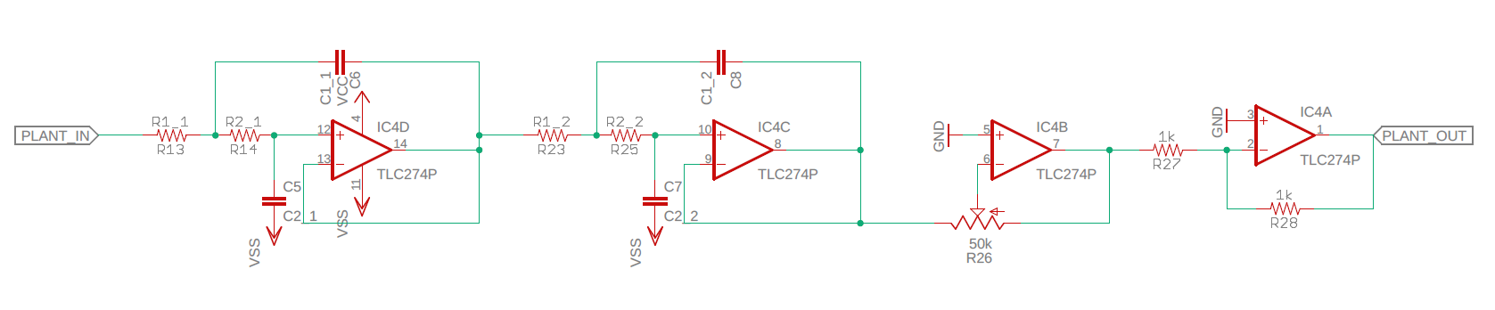
In order to accommodate different plants, the LPF components do not have fixed values, instead they use labels which are populated by components whose values create different filter types shown in the table below. Note, the filters were designed using the Analog Devices, Analog Filter Wizard using the following parameters.
Your board will have one of these four different amplifier configurations. Take a moment now, examine the components in your board and determine which LPF is populating your board and fill in their values in the table below. The capacitor values are given because they cannot be determined by inspection.
R1_1 | R2_1 | R1_2 | R2_2 | C1_1 | C2_1 | C1_2 | C2_2
 |  |  |  | 100nF | 68nF | 100nF | 10nF

Converting PWM to DC
The role of the plant is to convert the PWM output from the controller into a DC signal that is compared against the reference input. Mathematically you can see this by representing the PWM waveform by its Fourier Series. Consider this series to have two types of components, DC and AC.
The DC component of the Fourier Series is the average value of the PWM waveform. Since the frequency of DC is 0Hz the low pass filter passes it through with 0dB of attenuation. Since 0dB of attenuation is “no change”, the DC value passes unchanged through the filter.
The AC components of the PWM waveform have frequencies which are integer multiples of the fundamental frequency, which is the frequency of the PWM waveform, roughly 1kHz. These frequencies are a decade higher than the corner frequency, 100Hz, which means that their attenuation is at least -80dB. This is a substantial attenuation which will block these harmonic frequencies from appearing at the output.
Hence, the only input to reach the output is the DC which is the average value of the PWM waveform, exactly what we want.
Use the Nyquist plot to estimate the gain margin of your plant.

Tune the PID Controller:
Now, lets see if you can tune the PID controller so that the output of the plant can track a 4Hz square wave. To do this you will:
- Insert the plant into the control loop by installing the jumpers on the PLANT INPUT and PLANT OUTPUT.
- Power on the oscilloscope, they take forever to boot.
- Turn on and configure the power supply to have 9V, 0.1A on channel 1 and 2. Leave the power supply on but disable the individual channels until everything is connected.
- Configure the power supply to generate +9V, GND, -9V, attach the respective terminals to the PID Controller using red (+9V), green (GND) and black (-9V) banana cables and alligator clips.
- Run a T-connected BNC from the oscilloscope function generator output to Channel 1 of the oscilloscope and to the FNC inputs on the PID Controller board. Attach the GND clip of the function generator to the the nearby GND.2 loop.
- Attach a probe to Channel 2 of the oscilloscope and connect it to the OUT header at the top of the PCB. No need for a ground clip, the function generator ground has already taken care of that.
- Enable channel 1 and 2 of the power supply and ensure that you are not hitting the current limit on either channel. If so, immediately disable both channels. You have something incorrectly connected. Fix and try again.
- Adjust the oscilloscope function generator to generate a 4Hz square wave with an amplitude of 1V.
- Enable channel 2, make it the same scale as channel 1 and place the GND references of the two channels in the vertical center of the screen.
Now it’s time to play with the PID knobs to get the output to track the input. Error! Reference source not found. shows my setup and tuned controller, you should try to do better.

